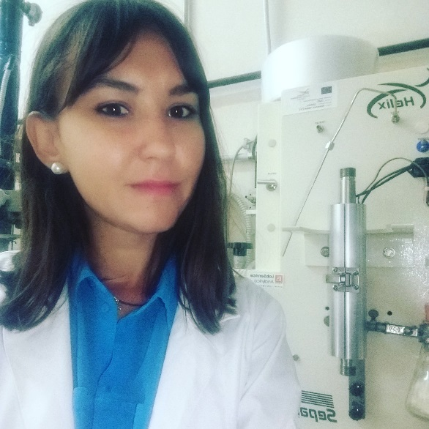

Who I am
My name is Theodora Ioannou, I am 25 years old Master student in Bioanalysis and I am from Thessaloniki, Greece.

My background
I studied Chemistry at the Aristotle University of Thessaloniki and during the final year of studies I had chosen the field of chemical analysis. In Greece I had a two-month traineeship at the Veterinary Hospital of Greek Army and before my work there is completed, I started searching other organizations in order to do traineeships and gain more experience in laboratory work. Through the research I had done on the internet I was impressed by the research projects that are available by ESMB and I decided to search more about this organization. So, since I contacted with professor Claire Hellio and professor Concetta Maria Messina allowed me to do this traineeship, directly after my Bachelor degree I joined the team of Laboratory of Marine Biochemistry and Ecotoxicology in Trapani (University of Palermo).
Currently I am master student and I am working again on my thesis at the same Laboratory in Trapani.

My project in the ESMB placement

My project was about the isolation and evaluation of bioactive compounds from marine, extremophiles and halophyles species. Among these, I focused on marine algae, plants and on the halophyles species of Calendula which are endemic to Western Sicily and grow in areas with high salinity. For this, I performed extraction techniques with different solvents from chemical solvents to supercritical in order to find the best solvent that gives the highest yield of bioactive compounds and evaluated the bioactivity of different extracts by using assays like DPPH, reducing power, total phenol content. Since joining the lab, I worked with state-of-the art equipment and gained experience in laboratory work. I studied literature and learned about bioactive compounds such as phenolic compounds, their importance to human and organisms and the possible use in pharmaceutical, nutraceutical and cosmetic industry. The results of this study were included in a submitted paper with me as co-author.

I really feel blessed for finding this organization because my internship through ESMB gave me academic purpose, as I am impressed by marine organisms and continue my research in this field of science.

It was an amazing experience living in Sicily for 3 months and working in a top research laboratory.

