ANGELIKI KOSTOGLOU

MY PROFILE
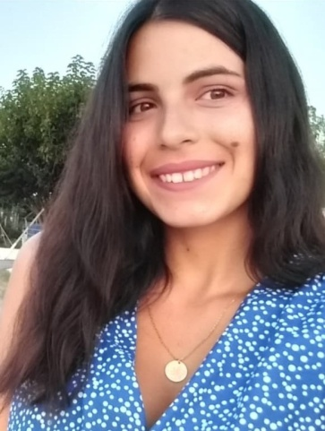
My name is Angeliki Kostoglou, I am 21 years old and I come from Serres, Greece. I am an undergraduate student in Department of Chemistry of Aristotle University of Thessaloniki. I was grateful for finding out the ESMB network; and for being an Erasmus+ student in University of Palermo, doing my traineeship in Laboratory of marine Biochemistry in Trapani!
My traineeship project for Bachelor degree at the Laboratory of Marine Biochemistry and Ecotoxicology
My project in ESMB placement was the extraction of bioactive compounds from marine organisms and the evaluation of the effects in cell culture for pharmaceuticals and cosmetics application. During almost the one month that I stayed in Trapani, I was getting accustomed with the laboratory techniques, such as isolation; principally of antioxidants, carotenoids, lipids from microalgae, chemical and supercritical extraction, biochemical tests, and instrumental analytical techniques. The most interesting addiction in my background is that; My supervisor in laboratory, Prof. Concetta Maria Messina let me continue my traineeship with teleworking when the COVID-19 was in peak in Italy, and actually helped me significally to travel back to Greece to be safely with my family! Now, two months after completed my traineeship, richer of experience and knowledge, I owe many thanks to my professors, to PhD and Master students from laboratory in Trapani, and of course to ESMB network for giving me the opportunity to practice in a top marine biochemistry laboratory and inflaming my aspiration to specialize in biochemistry!

