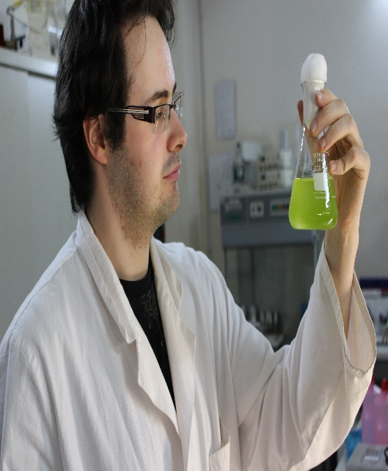
Who am I?

I’m Yann Péricot, a 23 years old post-graduate, in second year of “Biotechnological valorization of marine resources” at the European Institute for Marine Studies (Plouzané, France)

My background
After high school, I followed a Bachelor degree in biology in Brest (UBO). And after this, I joined the European Institute for Marine Studies to pursue a Master in marine biology. In the second year, I specialized in marine biotechnology.
In this final year, we need to do a five months internship. I wanted to do my research project abroad because I thought it will be a really enriching experience. At first, I had the plan to go to Canada but I couldn’t because of administrative problems. So, I was really down about it but then one of our professors told us about the ESMB placements. I was really thrilled by the idea so I sent my application in two countries (Italy and Germany). And I got accepted for a project in Sicily, where I am right now.

My project in the ESMB placement
My project in this internship is to evaluate bioactivities of marine compounds. To isolate and identify them, and then find ways to maximize the yield and the bioactivity of these molecules. Since joining the lab, I learned a lot about the laboratory work including tests of biological activity which are in high demand for biotechnology research but also highly sought after by the pharmaceutical, cosmetic and nutraceutical industries. I learned how to extract fatty acids, proteins, pigments and phenolic compounds from animal and vegetal matrices and how to assay lipid peroxidation, reducing power and antioxidant capacity. I also learned how to manage a microalgae strain in a photo bioreactor at lab scale. All these experiences and knowledge could only help me for my future projects.
I thank the ESMB placement scheme for granting me this internship. And if possible, I would like to give my impression after the training course, to give a better feedback. But the experience is already very rewarding and Sicily is a really nice place to be. So if you either see another ESMB placement in Sicily (or other places), give it a try!

